**DATA SOURCE BANK**

**Objective**

A dataset of a fake bank – The Data Source Bank (DSB). The dataset contains numerous transactions and the dataset also contains transactions of other banks. The dataset has to be cleaned and 3 outputs are to be obtained from this exercise –

**Dataset**

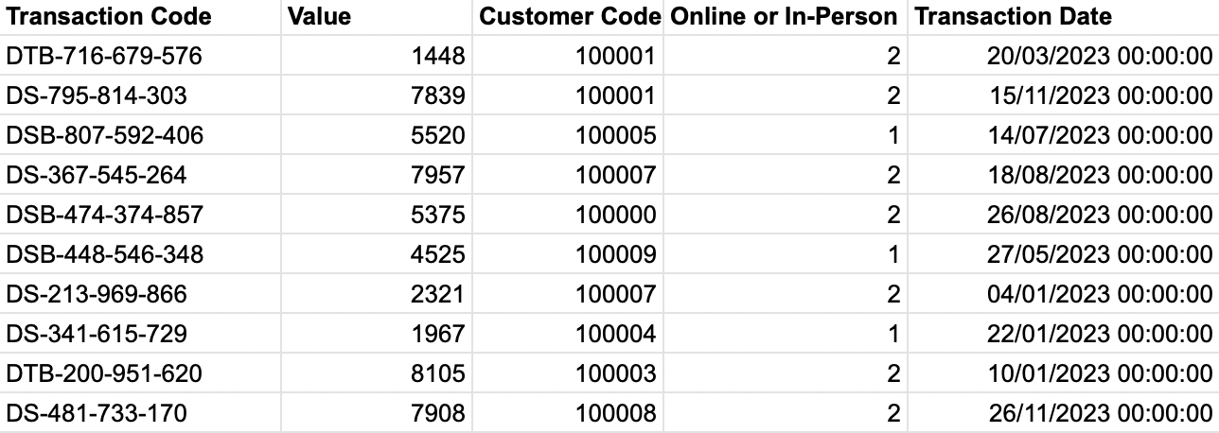

**Output required - 1: Total Values of Transactions by each bank**

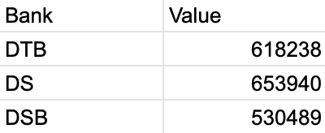

**Output required - 2: Total values by bank, day of the week and type of transaction**

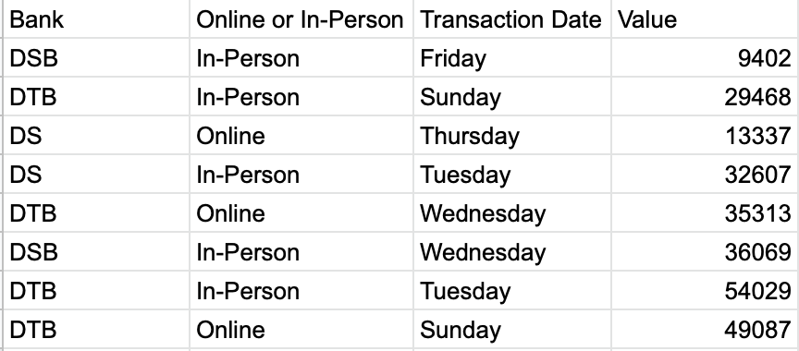

**Output required - 3: Total values by bank and customer code**

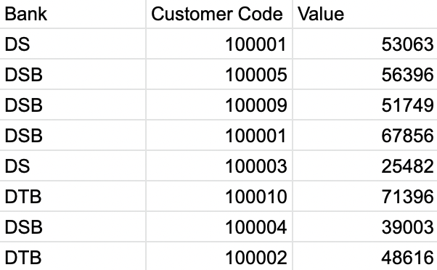

***Dataset link:*** *https://preppindata.blogspot.com/2023/01/2023-week-1-data-source-bank.html*